Exercise:

Unpacking the Knowledge Management Tools and Techniques Matrix
Objectives
- To understand the differences and similarities between the four quadrants of the Knowledge Management (KM) Tools and Techniques Matrix while using a card-sorting approach
- To understand how different KM tools and techniques can be combined to maximize knowledge sharing
Overview
The purpose of this exercise is to help participants get more familiar with the four quadrants of the KM Tools and Techniques Matrix (Ask, Tell, Publish, and Search approaches in KM), and with some specific KM tools and techniques that fall under each quadrant. Through use of a card-sorting exercise, the exercise will also put into practical use a specific technique that can be used to get input and feedback on how to structure information and information products.
Time
Total: 60 minutes
The Activity Leader should explain the exercise (5 minutes) and allow time for the participants to sort the cards (10 minutes). After that, participants should share their thoughts in small groups (20 minutes), then allow the groups to report out and discuss (25 minutes).
Advance Preparation
For this exercise, you will need 46–50 cards per participant.
- 32 cards for the individual KM tools and techniques
- 4 cards for the quadrant categories under which the KM tools and techniques fall
- 10–14 blank cards in case the participants think of additional KM tools and techniques not already listed
Write each of the terms listed in the Exercise Worksheet at the end of this document on each set of cards. Or you can print these terms, using self-adhesive labels and a word processor if possible, and tape each term onto an individual card. Create one set of cards for each participant.
Activity Steps
Step 1: Individual sorting
- Give each participant a set of cards with the terms listed in the Advance Preparation section.
- Explain that the ASK, TELL, PUBLISH, and SEARCH cards are the 4 main quadrants or “buckets” and that the other cards are the KM tools and techniques that need to be sorted into the 4 main quadrants. Participants should have already received background information on the KM Tools and Techniques Matrix through the Step 3: Create and Iterate, Part 1, presentation slides included in the KM Training Package for Global Health Programs.
- Ask the participants to individually sort each KM tool and technique card into the Ask/Tell/Publish/Search quadrant where they feel it fits the best. Depending on space availability, the participants can either sort their cards on a table in front of them or they can tape them onto a wall.
- If participants feel a particular KM tool or technique card fits into more than one quadrant, they should place the card in the quadrant they think would be the best fit. However, they can also make duplicate cards for that tool/technique and place the tool/technique under multiple quadrants if they feel the tool/technique truly straddles multiple quadrants.
- If participants think of additional KM tools and techniques that aren’t already on the provided cards, they can create new cards for those tools/techniques and place them under the appropriate quadrant card.

Step 2: Small Group Discussion
- Participants should group themselves together with two to three other individuals. The participants should share their sorted ASK, TELL, PUBLISH, SEARCH matrix with each other.
- Participants in each group should discuss and make note of similarities and differences in how they sorted the cards.
- Some questions they can discuss together include:
  - Were any KM tools or techniques difficult to place under just one quadrant? If yes, which ones? Why?
  - Were there any quadrants (ASK, TELL, PUBLISH, SEARCH) that were easy to sort and others that were difficult? If yes, which ones and why?
  - Did any participant create new cards for KM tools or techniques that weren’t already covered in the given cards? If yes, what were they? Do the other participants agree on where the new cards should be placed?
- Participants in each group should work together to finalize the “group sort” that they will present to the larger group.

Step 3: Report Out
Each small group should take a few minutes to share the matrix they developed with the large group. For an example of how the KM tools and techniques are sorted in the ASK, TELL, PUBLISH, and SEARCH quadrants as included in the KM Training Package for Global Health Programs, see the Appendix at the end of this Exercise Guide.
Once all the small groups have shared their group matrices, the large group can consider the following:
- How can these KM tools and techniques be combined to promote greater knowledge sharing?
- How are the tools and techniques related? How are they different?
- Can you “push” and “pull” information in each quadrant? Or are particular quadrants better at “pulling” vs. “pushing” information?
- Which KM tools and techniques seem appropriate to undertake within your current environment?

Exercise Worksheet:
KM Tools and Techniques Matrix: Terms for the Each Set of Participant Cards

ASK | Knowledge cafés
TELL | Knowledge harvests
PUBLISH | Meetings
SEARCH | Net-Map
After-action reviews | Peer assists
Blogging | Podcasts
Brownbags | Reports
Case studies | Resource centers/libraries
Coaching | Share fairs
Communities of practice | Simple/advanced search
Conferences | Storytelling
eLearning | Study tours
Facets/filters | Taxonomies
Fact sheets | Teaching
Guides | Videos
Handbooks | Webinars
Interviews | Websites
Intranets | Workshops

APPENDIX. The KM Tools and Techniques Matrix
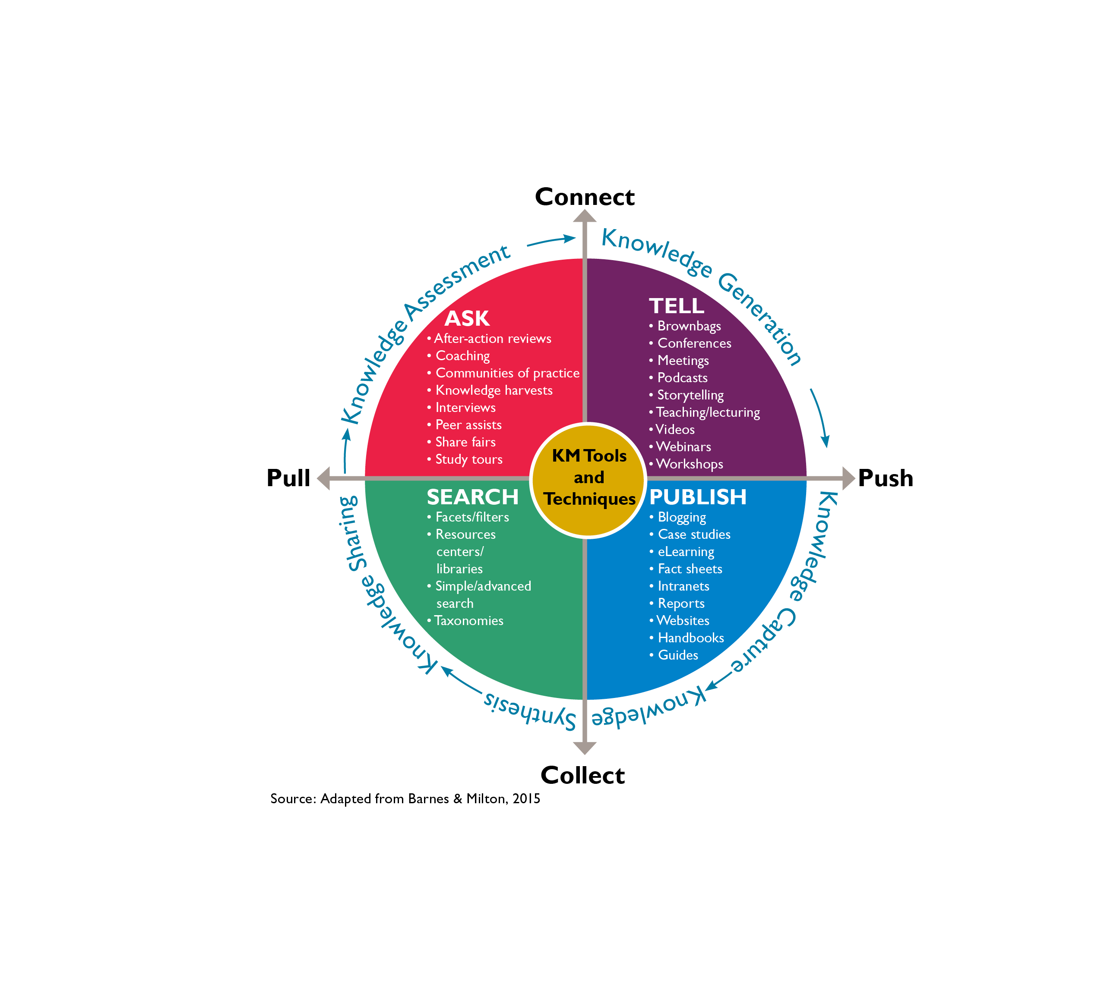
- Asking approaches, such as after-action reviews, knowledge cafés, peer assists, and other types of events and meetings, can be helpful for eliciting tacit knowledge
- Telling approaches, such as conferences, webinars, and workshops, are useful for conveying knowledge to defined groups of people
- Publishing approaches, such as job aids, e-learning courses, or websites, are efficient tools for sharing explicit knowledge with large groups of people
- Searching approaches, including libraries, taxonomies in databases, and facets or filters on search engines, allow people to pull the information they need, when they need it

