Expectation Board for Evaluation of Training
Overview of the Expectation Board
This simple yet effective low-tech evaluation tool is used to foster participant engagement throughout a training workshop, conference, or meeting. It is a way to visually track progress and encourage real-time feedback and critical thought. The qualitative nature of the expectation board complements the quantitative nature of another evaluation activity, the audience response system.

To implement the Expectation Board, ask participants to write their expectations for the workshop, conference, or meeting on pieces of paper and stick them onto a board or wall, labeled at the top “Expectations Set.” Throughout the event, ask participants to assess whether their expectations have been met. If their expectations have been met, participants should move the papers that state their expectations to an adjacent board, labeled at the top “Expectations Met.”

Objectives of the Expectation Board
- Understand participants’ expectations
- Respond to participants’ expectations
- Assess whether participant expectations were met

When To Do It and How Long It Takes
This activity will take approximately five minutes to explain during the pre-session evaluation. Participants will need five additional minutes to write down their expectations and post them during the first tea break. The facilitator should take two minutes prior to each subsequent break to remind participants to check if their expectation(s) have been met and act accordingly. Wrap-up of this activity will take approximately 10 minutes and will be discussed during the evaluation on the last day of the training.
Role of the Facilitator
The facilitator of this activity will need to explain the activity, remind participants to evaluate their expectations throughout the event, maintain the expectation board throughout the event by grouping similar expectations, and report on the findings twice—once during the middle of the event and once at the end.
Implementing the Activity
- Before the event, the facilitator will ensure he/she has: (1) access to two large walls or boards, and (2) enough space for participants to easily see the wall or boards.
- The facilitator will bring colored cards (sometimes referred to as Visualization in Participatory Program (VIPP) cards), or half sheets of colored paper, so that each participant has two colored cards/paper. The activity is more visually effective if several different colored cards/paper are used; however, each participant should be given only one color.
- Each wall segment or board will have a title at the top. The first will read “Expectations Set” and the second will read “Expectations Met.”
- Timing and process:
  - Opening session: 5 minutes
    - Five minutes to explain the activity and ask for support in handing out the cards.
      - Each participant should be given two cards, both the same color.
      - Remind participants to remember what color card they wrote on so they can easily identify their card throughout the conference.
      - During the explanation of the activity, it is important to not only state the objectives of the activity, but to also restate the objectives of the event so that participants’ expectations are relevant to the objectives of the event.
      - The facilitator should illustrate how the exercise works by writing an example expectation on a card and posting it to the board.
      - Trainers should also participate in the activity.
  - First coffee break: 5 minutes
    - Five minutes for participants to write down one to two expectations. Each expectation should be written on a different card.
      - Once everyone has finished filling out their expectations, the facilitator should help participants post their cards on the “Expectations Set” side of the board.
  - Reminders: 2 minutes
    - Reminders should be given at each coffee and lunch break. Participants will be asked to re-evaluate whether their expectations were met and move their cards accordingly.
  - Middle and end of training: 10 minutes each
    - The facilitator should share the results of the expectation wall with participants twice—once during the middle of the training and once at the end.
      - At these points, the facilitator could include tallies of the number of expectations that were met.
      - These points could also be used as opportunities to discuss the expectations that were not met and how they could serve as objectives for future meetings.
Additional Considerations
- If the setup of the room and wall or boards allows, move the expectation board to the main hall at the beginning of each day so participants can see and feel the progress being made at the event as they enter the venue. This will also serve as a reminder to assess their expectations throughout the event.
- In addition to doing a final tally of the expectations met at the event, the facilitator could also present tally numbers of expectations met each day.
- The facilitator should bring a roll of tape or pushpins to ensure the cards stay on the board throughout the duration of the event (even if the cards already have adhesive on the back because often the adhesive is not strong enough).

Example
A: At the beginning of the meeting  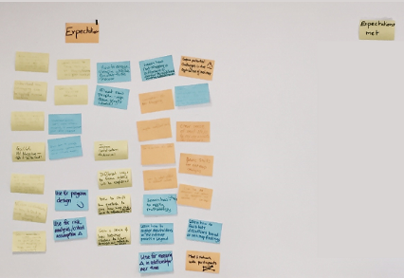 | B: Midway through Meeting  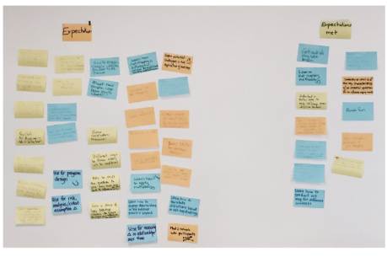
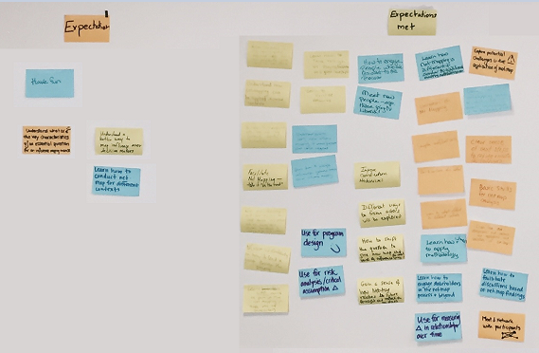
C: At the end of the meeting

